Computer Networks (CS303)

Assignment - 8

**U19CS012**

1) Implement **Static Routing** in Cisco Packet Tracer.

**Step 1**: Select 6 PC’s, 3 Switches and 3 Routers and Place them as Shown in Figure Below. 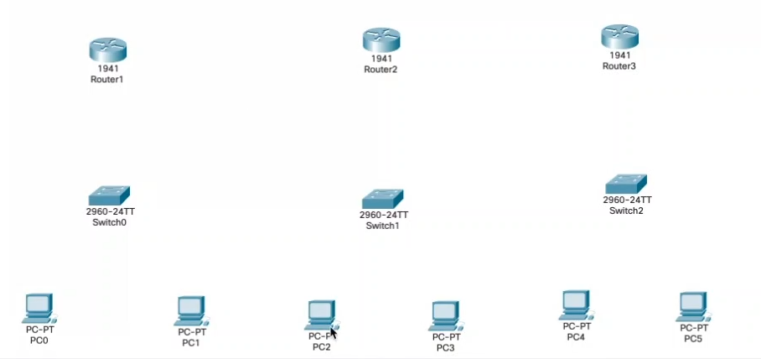

**Step 2**: Also Connect them using Wire. Basically, we want to Develop 3 Network consisting of {2 PC, 1 Switch and 1 Router}.

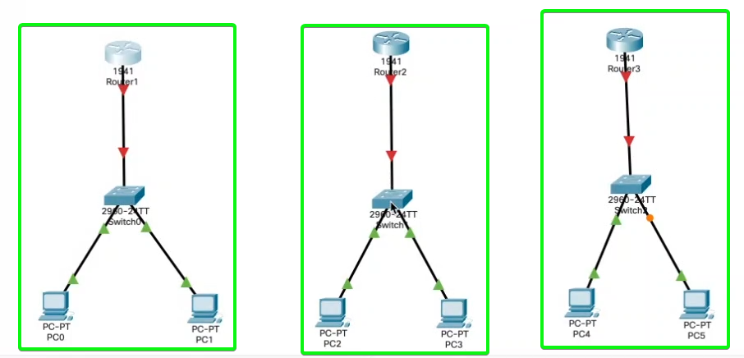

**Step 3**: Since we require 3 Points for Connection, we will add “**HWIC-2T**” [High Speed Interface Card]

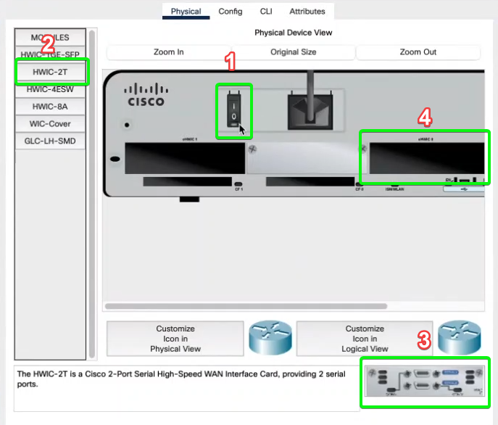

Add it for all three Routers.

**Step 4:** Connect the Routers with Automatic Wiring.

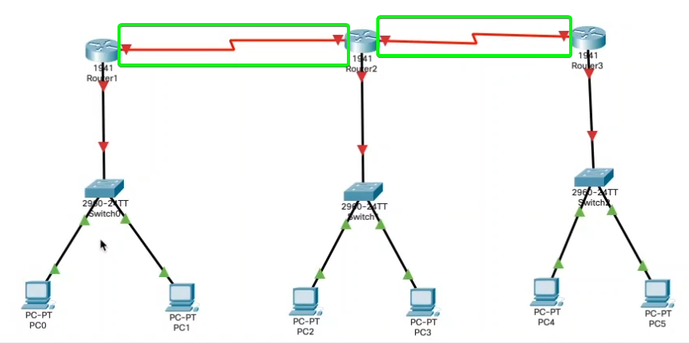

**Step 5**: Configure the IP Address of Each PC as shown below.

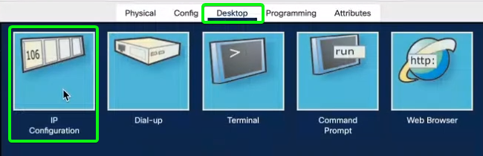

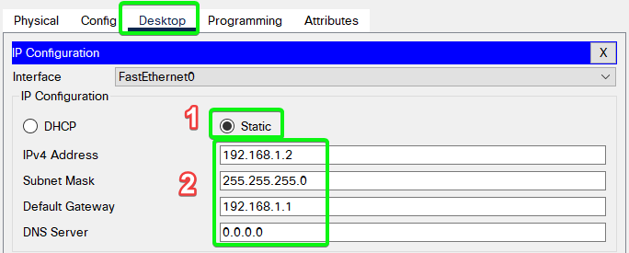

Also, Don’t Forget to Configure the Default Gateway.

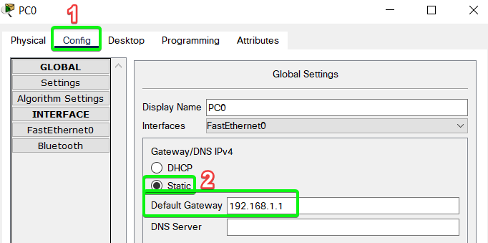

**Step 6**: Configure each Router as shown below.

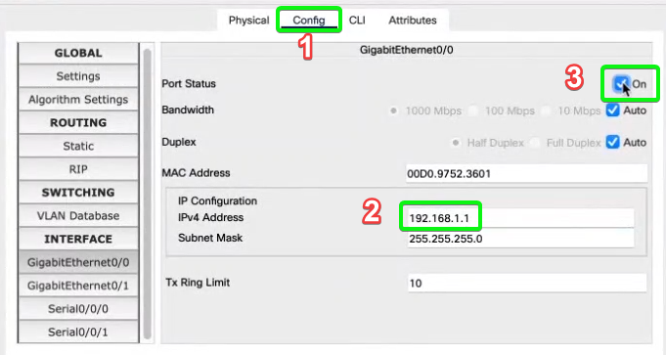

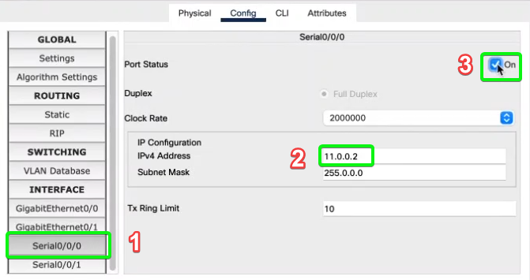

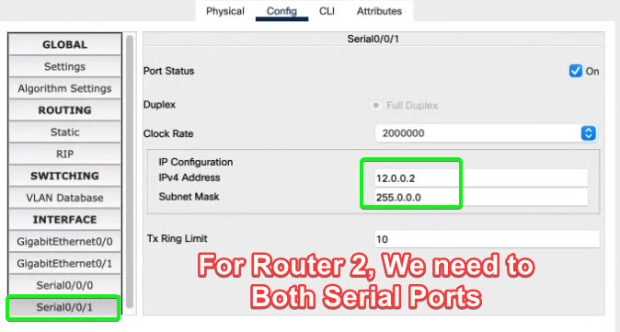

**Step 7**: Label Each PC and Router as Shown Below.

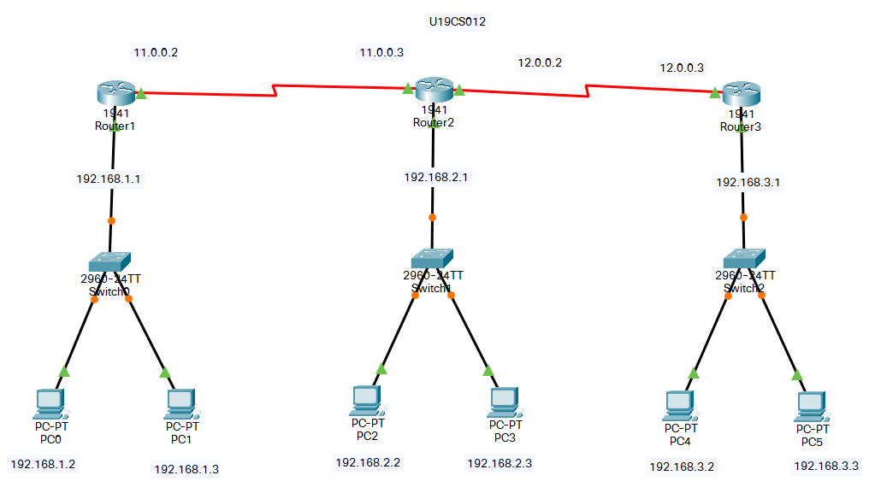

**Step 8**: Add Static Routes Paths for Each Router

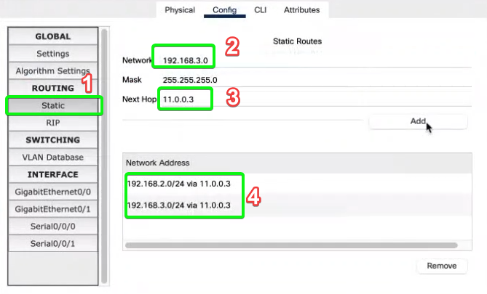

**Router 1**: To Reach From 192.168.1.0 to {192.168.2.0 & 192.168.3.0} we need to Hop via {11.0.0.3}.

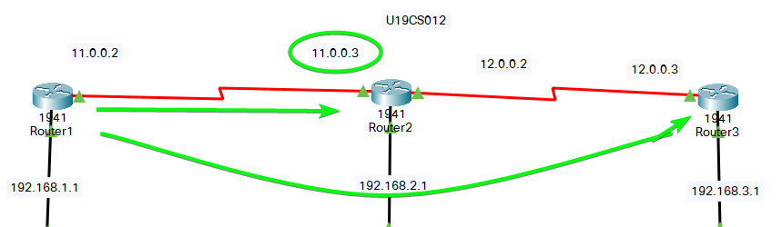

**Router 2**: To reach From 192.168.2.0 to {192.168.1.0} we need to Hop via {11.0.0.2}.

To Reach From 192.168.2.0 to {192.168.3.0} we need to Hop via {12.0.0.3}.

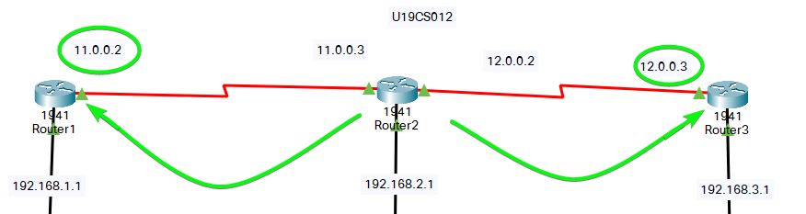

**Router 3**: To reach From 192.168.3.0 to {192.168.1.0 & 192.168.2.0} we need to Hop via {12.0.0.2}.

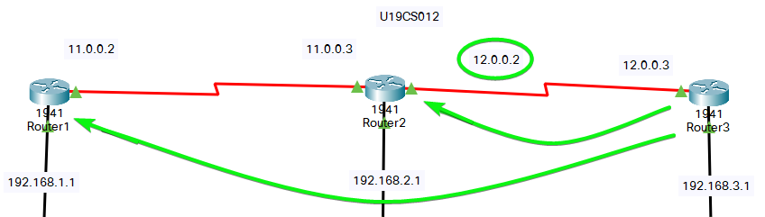

**Simulation**

Static Routing Step 1

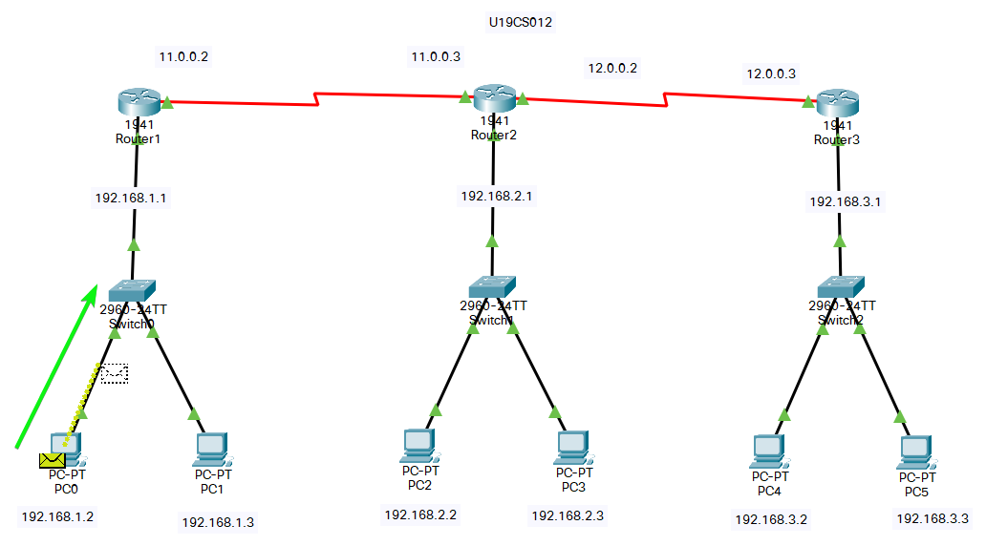

Static Routing Step 2

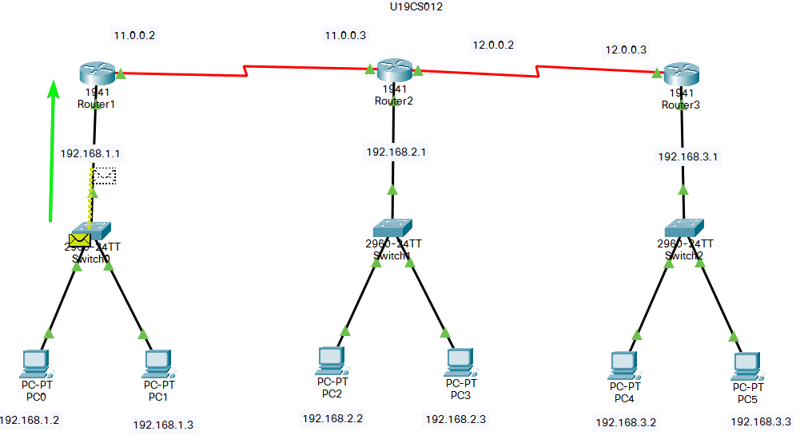

Static Routing Step 3

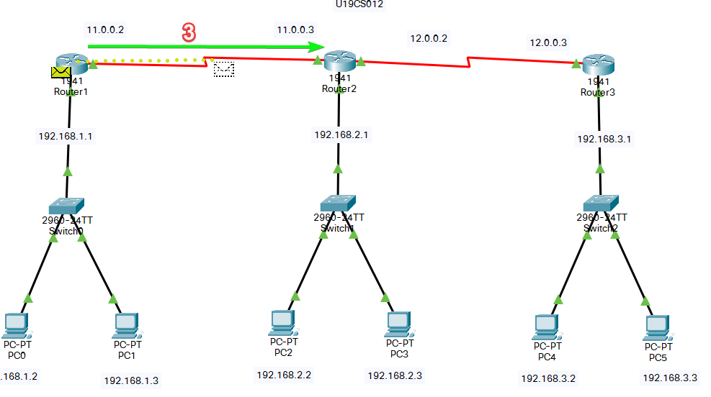

Static Routing Step 4

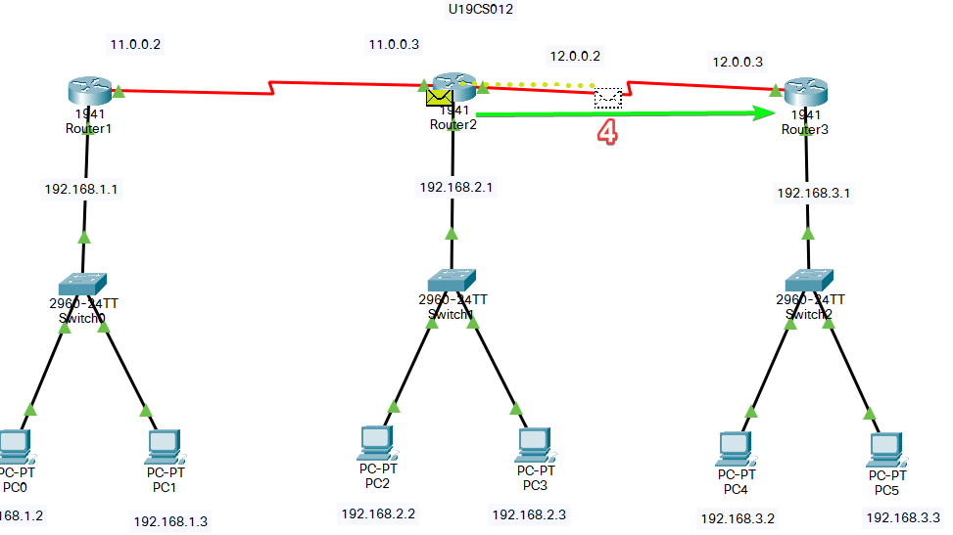

Static Routing Step 5

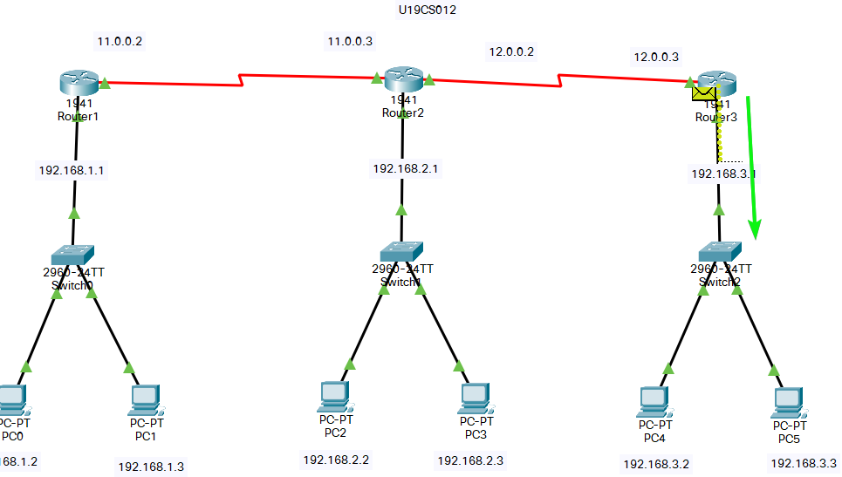

Static Routing Step 6

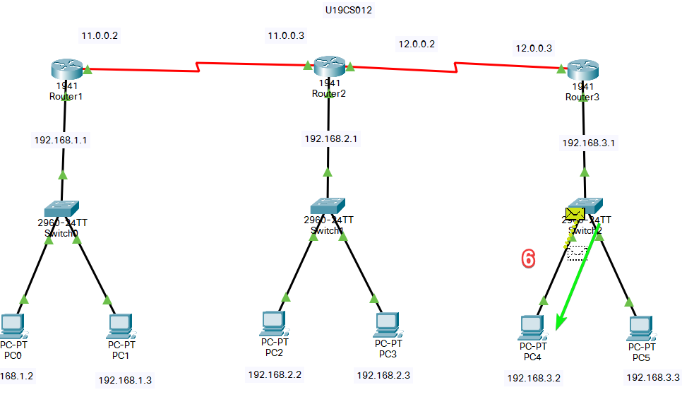

Static Routing Step **7-12**

Acknowledgement is Send Back via Same Route.

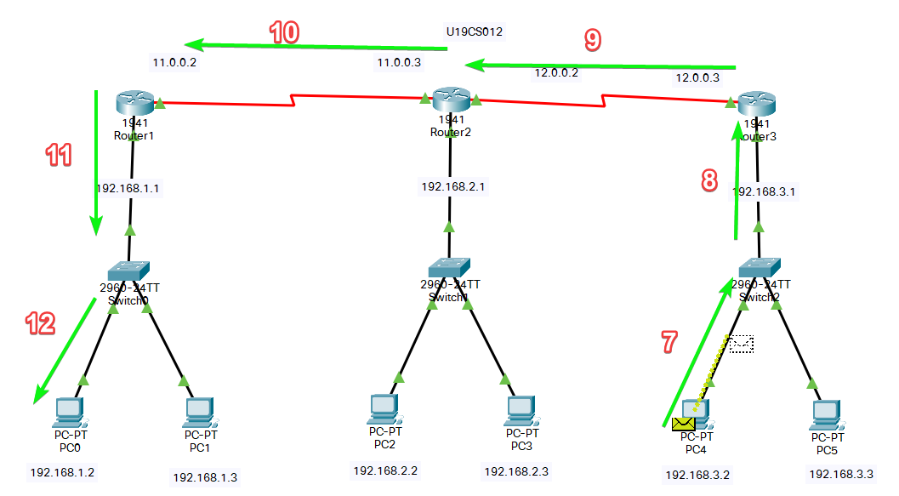

We have Successfully Implemented Static Routing in Cisco Packet Tracer.

2) Implement **Dynamic Routing** in Cisco Packet Tracer.

**Step 1**: You can make the Configuration of 6 PC’s, 3 Switches and 3 Routers again for Dynamic Routing [Do Not Perform Step 8 {manually setting the Static Routes}]

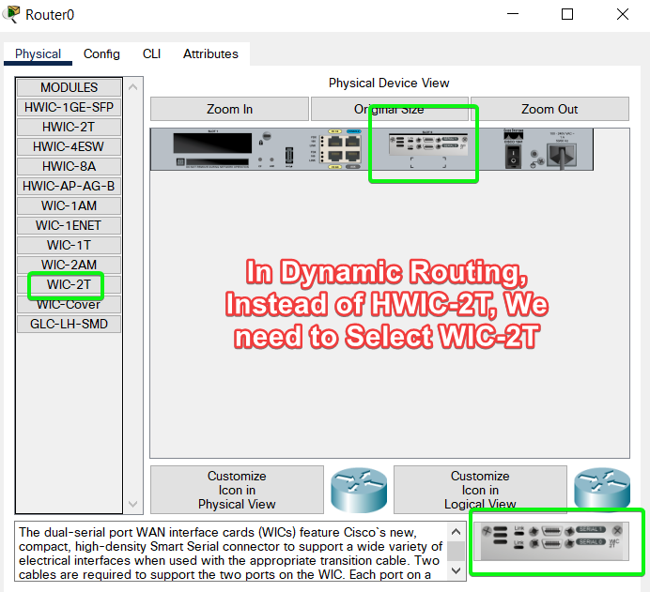

**Step 2**: Configure the RIP in Each Router

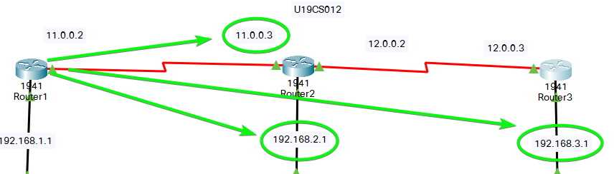

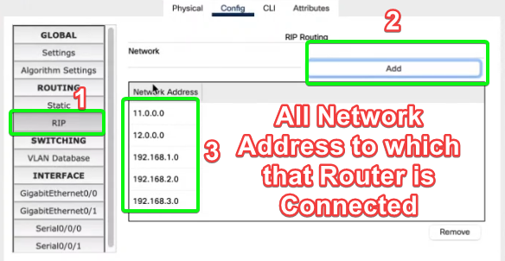

Router 1 is connected to 5 Network Addresses {192.168.1.0, 192.168.2.0, 192.168.3.0, 11.0.0.0, 12.0.0.0}

Configure the Router 2 and 3 in Similar Fashion.

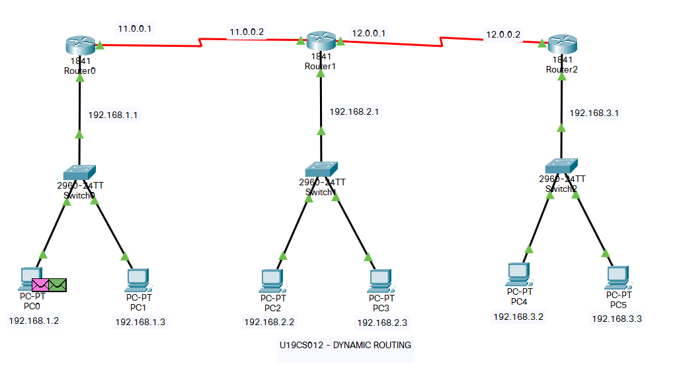

**Simulation**

Dynamic Routing Step 1

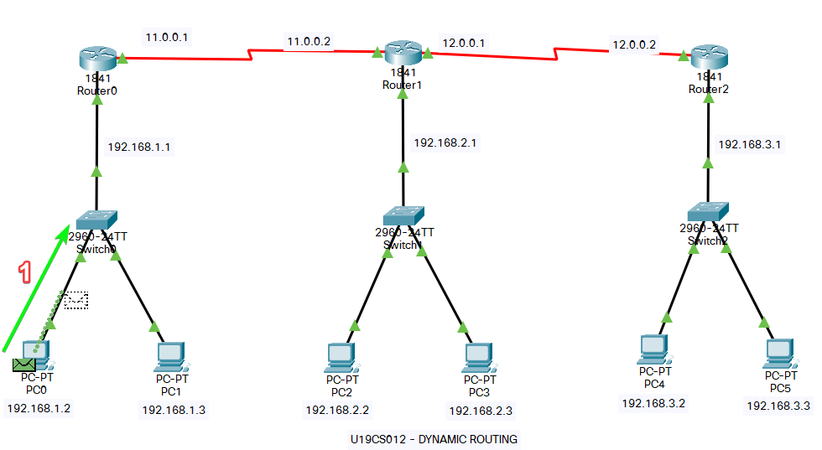

Dynamic Routing Step 2

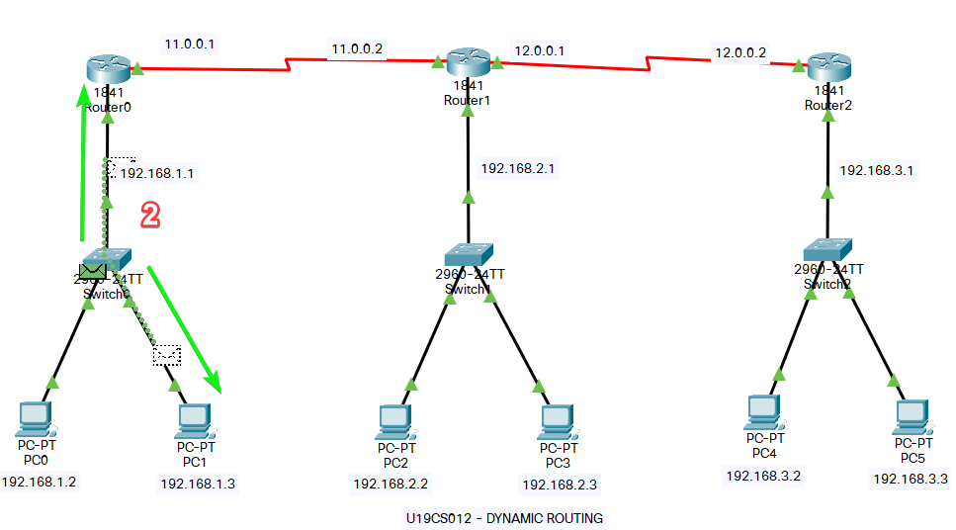

Dynamic Routing Step 3

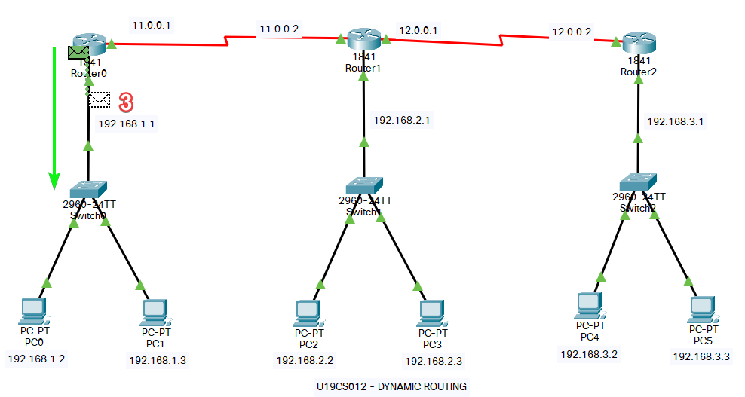

Dynamic Routing Step 4

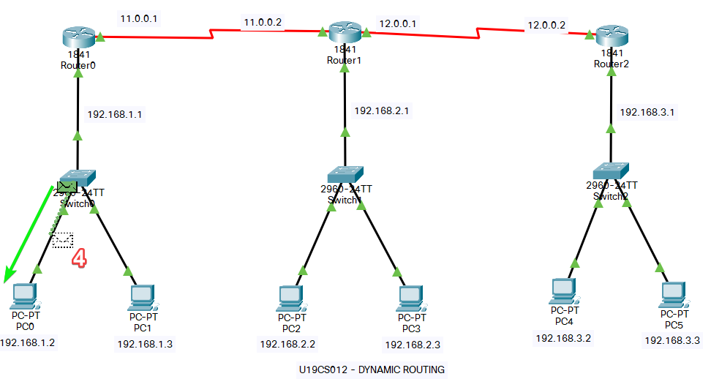

Dynamic Routing Step 5

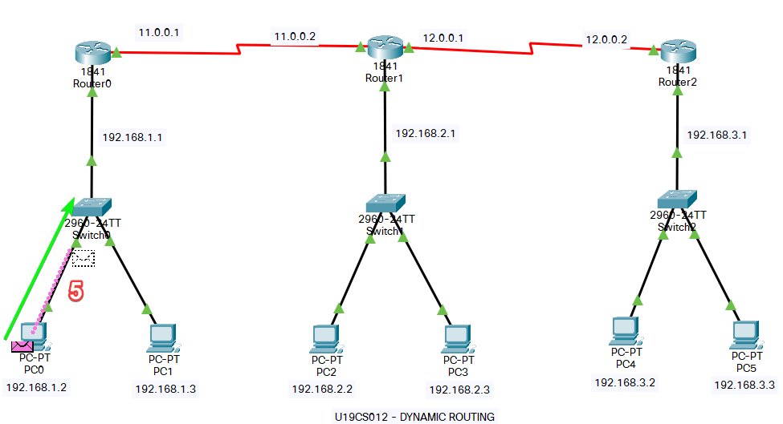

Dynamic Routing Step 6

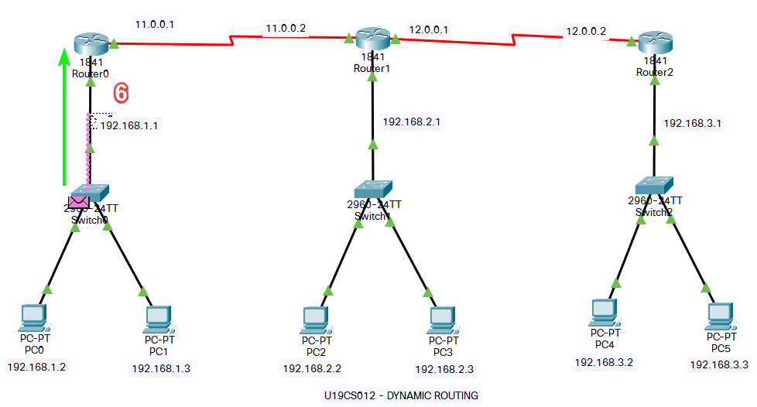

Dynamic Routing Step 7

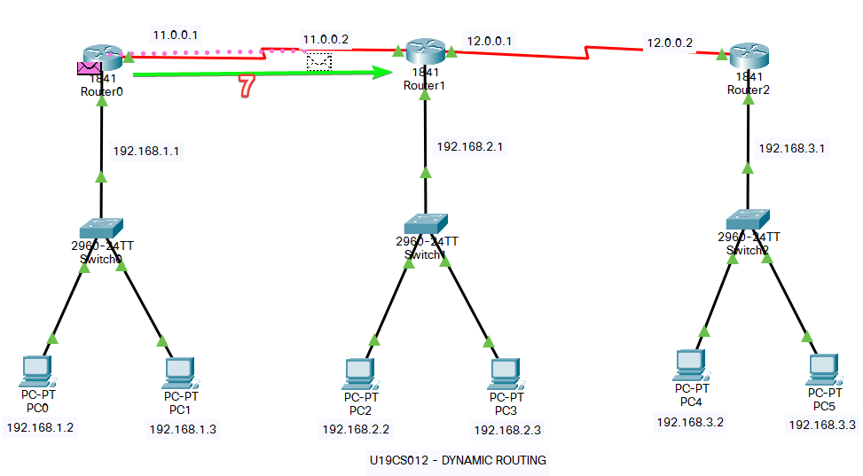

Dynamic Routing Step 8

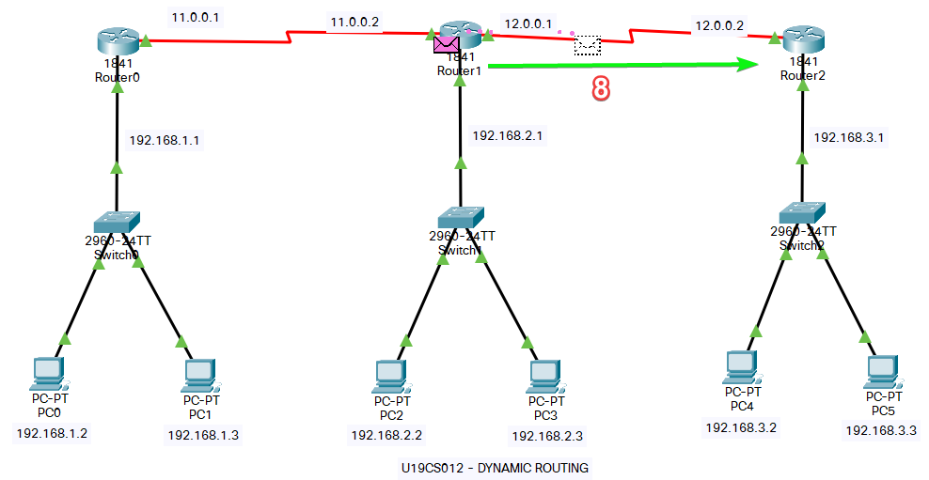

Dynamic Routing Step 9

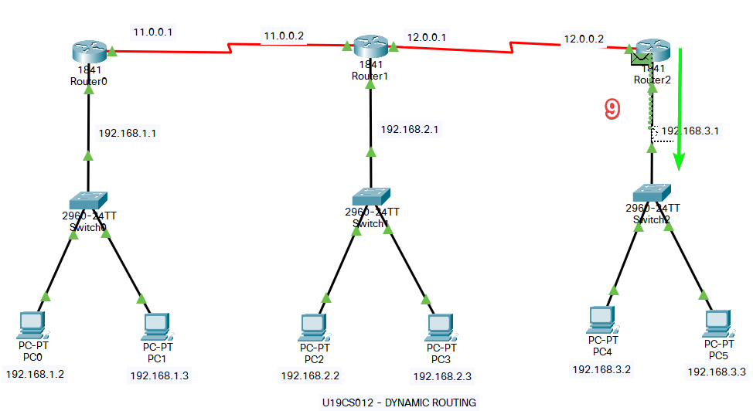

Dynamic Routing Step 10

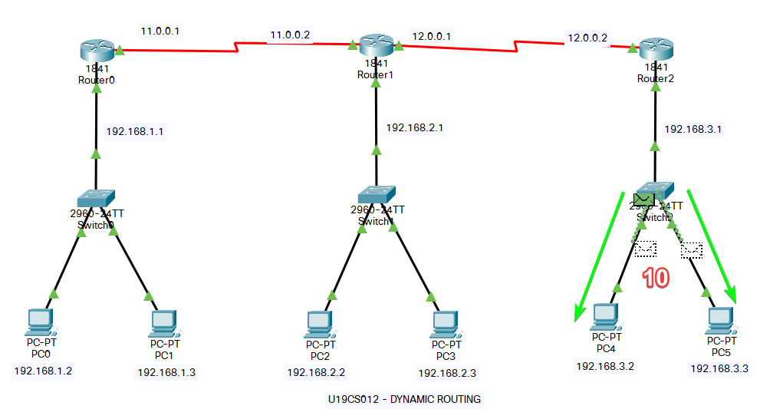

Dynamic Routing Step 11-16

Acknowledgement is Send Back via Same Route.

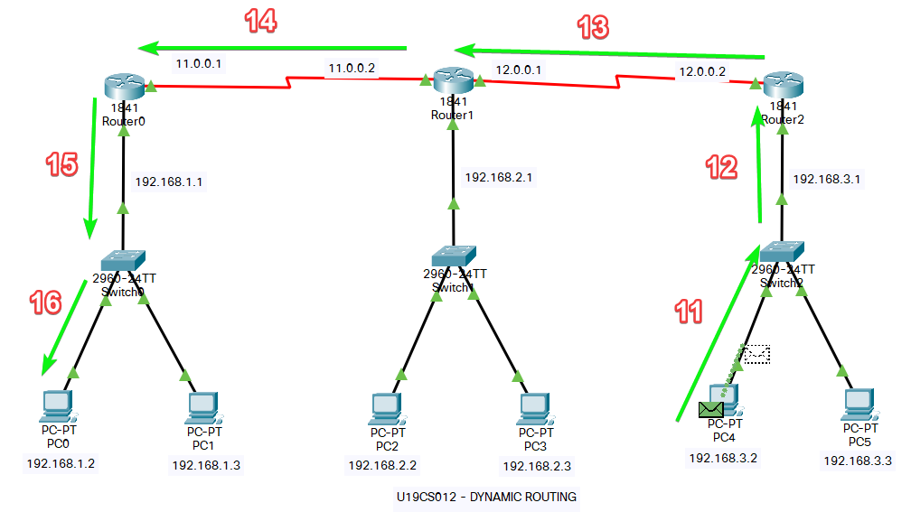

We have Successfully Implemented Dynamic Routing in Cisco Packet Tracer.

SUBMITTED BY:

**U19CS012**

BHAGYA VINOD RANA